CHIPPER OPERATOR SPECIALIST WORKSHOP
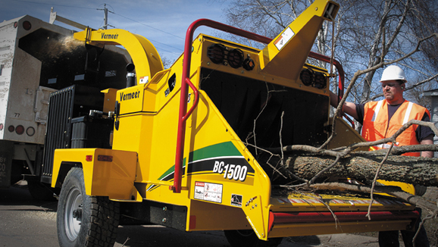
3.75 ISA CEUs and TCIA CTSP Credits Available!!
A wood chipper safety training workshop will be held March 2 at the Habersham Extension Agriculture Service Center, 555 Monroe St, Clarkesville, in Habersham County at 12;30 p.m. The workshop is being sponsored by the Habersham County Cooperative Extension Service, the Georgia Arborist Association, the Georgia Forestry Commission, Piedmont Arborist Consultant, Chestatee-Chattahoochee RC&D Council and Vermeer Tree Care.
Injuries involving brush chippers are a significant concern for tree care companies and landscape employers as well as the tree care workers who operate the equipment. Strong anecdotal information from the field indicates that chipper operators receive little or no formal training on chipper operation and field maintenance.

Accidents at job sites can happen at any time, and tree care professionals must know how to react. When a tree worker is injured or incapacitated, fellow crew members are the first to respond to the emergency situation.

The Tree Care Industry Association’s Tree Care Academy Chipper Operator Specialist course is designed to train tree care personnel in hazards, as well as accepted practices for brush chipper operation and other associated tasks. This course will provide tree crew workers formal training that will increase involvement with overall OSHA safety compliance and self-policing.

The Chipper Operator Specialist Workshop will be held March 2 from 12:30 – 4:45. To register please contact the Georgia Arborist Association at info@georgiaarborist.org or call (404) 913-1422.

The Tree Care Industry Association Foundation (TCIAF) provides grants for job and safety training to minimize deaths and injuries, and to promote overall workforce safety that is critical for the tree care industry. To learn more about how TCIAF can bring quality, local and affordable safety training to working arborists in your area please contact TCIAF at 800-733-2622 or asti@tcia.org.

